**Religious Learning Using The Sing A Song Method At**

**The Sungai Buloh Guidance Center, Kuala Lumpur**

Robie Fanreza1*, Nurman Ginting2, Arwin Juli Rakhmadi3 , Riyan Pradesyah4

1,2,3,4 Universitas Muhammadiyah Sumatera Utara, Medan, Indonesia

*Corresponding Author:

Email: [robiefanreza@umsu.ac.id](mailto:robiefanreza@umsu.ac.id)

|  |
| --- |
| ***Abstract*** *.*  *Based on the results of observations and preliminary studies, it was found that students' ability to understand religious subjects at the Sungai Buloh Guidance Studio, Kuala Lumpur, was still low, this was evidenced by the process and learning outcomes. This activity is usually held once a week at the Sungai Buloh Guidance Studio. In the activity of conveying religious learning material, there were educators who delivered religious subjects using non-cooperative methods. It was found that when students received religious subject matter, there was a delay. Then there has been no maximum effort to use the cooperative method to increase students' understanding of religious subject matter by educators. The solution offered to the Sungai Buloh Guidance Center is to provide training to educators using the Sing A Song Method in delivering religious subject matter to students. The Sing A Song method is a way of teaching and introducing religious subject matter with a singing method that uses certain lyrics that are sung. Usually the lyrics of the songs are adjusted to the subject matter that will be taught to students which is done repeatedly in this training. Initially, educators were given the opportunity to make song lyrics adapted to the subject matter and then also adapted to the tunes of songs that were easy for students to memorize. Then educators practice how to deliver and teach directly to students, and later will be accompanied by mentors provided. After that an evaluation was carried out, by means of which the participants read one verse of the Koran, so that they could find out the level of understanding that had been achieved.*  ***Keywords:*** *Religious Learning, and Sing A Song Method*. |

1. **INTRODUCTION**

The people who live around the Sungi Buloh Guidance Center are dominated by Indonesian citizens who work as Indonesian workers of various ethnicities, thus making some of the community establish tutoring centers for the children of these workers. Indonesian citizens are not in the same Sungai Buloh tutoring studio complex, but are scattered according to their respective original residences, so that the social life of the community is shown by community activities.Based on the results of observations and preliminary studies, it was found that students' ability to understand religious subjects at the Guidance Studio was still low, this was evidenced by the learning process, which was usually carried out once a week at the Sungai Buloh Guidance Studio. In the activity of delivering religious learning material there were educators who delivered religious subjects using the classical method, it was found that when receiving religious subject matter there was a delay in receiving religious subject matter to students [1].

There is no attempt to use other methods in understanding religious subject matter by educators. The problem found and faced in the Sungai Buloh tutoring center is the low ability to use cooperative learning methods for students [2], this is due to their educational background, most of which are not from undergraduate education, so that their abilities are limited to transfer of learning materials.The solution offered to the Sungai Buloh guidance center is training for educators using the Sing A Song Method in delivering religious subject matter to students. Where the sing a song method is a way of teaching and introducing religious subject matter with a singing method that uses the lyrics that are sung. Usually the lyrics of the song are adjusted to the subject matter that will be taught to students which is done repeatedly in this training [3]. The service team consisting of Robie Fanreza and a team of researchers who have the ability to use the Sing A Song method. So that the readiness of the service team is seen as capable of increasing the ability of educators to understand religious subjects with the Sing A Song method for students in the Sungai Buloh learning center, Kuala Lumpur.

**II. RESULTS AND DISCUSSION**

In carrying out the activities of the international partnership community service program (PkM-KI), namely religious learning using the Sing A Song method at the Sungai Buloh tutoring studio. So the results achieved from these activities included an initial survey. The initial survey of the activities of the international partnership community service program (PkM-KI) was carried out consisting of three meetings, namely :

*First,* visiting the Sungai Buloh tutoring center to meet with the school and some of its teacher boards. The meeting was intended to convey technically the implementation of the international partnership community service program (PkM-KI). At the meeting it was discussed regarding the time of implementation of the activity, the place of implementation and the number of people who would take part in the international partnership community service program (PkM-KI). To the Sungai Buloh SB school, Mrs. Wiffy Zalina Putri suggested providing learning materials that were as easy as possible to be understood and applied to all participants in the Sungai Buloh tutoring center.

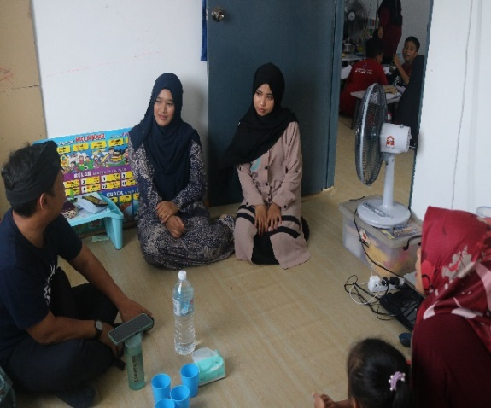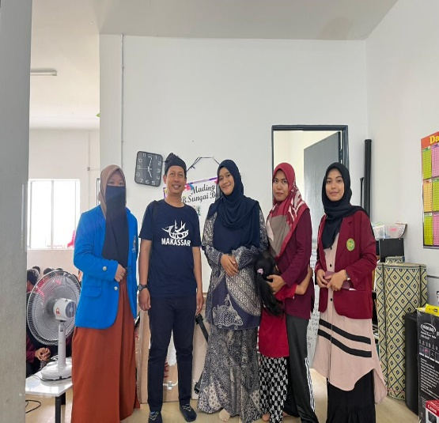

**Fig 1.**Visits and Hearings to the Principal

*Second,* holding a meeting with the Lecturer Team of the Faculty of Islam related to cooperative learning methods at the Muhammadiyah University of North Sumatra [4]. The meeting was held to discuss the use of the sing a song method so that it can be conveyed easily and lightly so as to assist the implementation of the international partnership community service program (PkM-KI). In this program, the research team acts as a speaker in the activity. The purpose of using this equipment is so that training participants can find out how to use the sing a song method both in theory and practice. After the PkM-KI team conducted the initial survey, there were many suggestions, both from the head of the Sungai Buloh study guidance center and the research team. From these various suggestions the committee for the international partnership community service program (PkM-KI) made various preparations both technical and non-technical related to the implementation of the international partnership community service program (PkM-KI) which will be held at Sungai Buloh SB . Then the preparations made by the team before carrying out the activities of the international partnership community service program (PkM-KI) are: *First,* by determining and preparing the material to be delivered in the activity. *Second* , the team then conducted a literature study on what media is suitable for simulating and what are the steps for using the sing a song method in religious learning material [5] .

*Third* , then the team chooses the right method and strategy for delivering training material using the sing a song method in making it easier to deliver religious learning material. *Fourth* , prepare a guidebook or textbook regarding the steps for using the method. *Fifth* , prepare tools and materials to practice how to read the translation of the Koran. The book used to understand using the sing a song method is a cooperative learning method book. The international partnership community service program (PkM-KI) is carried out from 08.00 to finish on Malaysian time. The training using the sing a song method was attended by 20 participants in the Sungai Buloh tutoring studio environment. The activity was carried out in four sessions, namely:

1. **Opening and Introduction Session**

Before the start of the international partnership community service program (PkM-KI), the activity was opened by the leadership or principal of the Sungai Bulah study guidance studio, namely sister Wiffi Zalina Putri. In the opening remarks of the international partnership community service program (PkM-KI), he said that a teacher must have many learning methods in delivering subject matter. At present the teacher must prepare himself before he gives or conveys subject matter to students, so cooperative methods are needed including the sing a song method. In addition, the principal also hopes that by holding this international partnership community service program (PkM-KI), there will be no more obstacles in conveying religious subject matter to students. At the end of his remarks, he gave great appreciation for the implementation of this international partnership community service program (PkM-KI) activity, and he also hoped that activities like this could be carried out at least once a year.

1. **Presentation and Question and Answer Session**

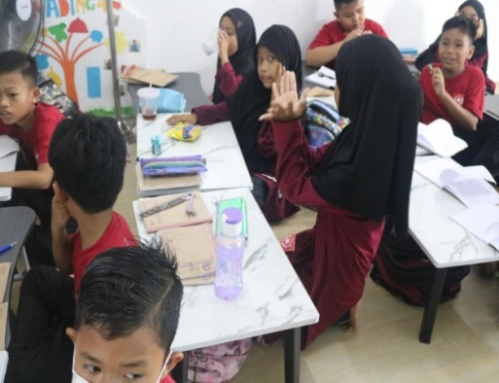In this training session, all participants will receive an explanation of various training materials, including the importance of using various cooperative methods in conveying religious subject matter, and how to use cooperative methods properly and correctly and the various existing methods. The first material was delivered by Robie Fanreza, regarding the importance of understanding and using cooperative learning methods for teachers. This is explained using various cooperative methods, making it easier for us to convey learning material. Then the speaker also explained about the use of the Sing A Song method.

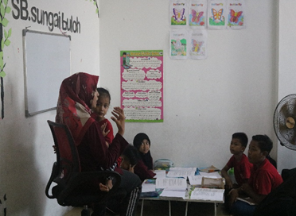

**Fig 2.** Question and Answer Session

1. **Practice Session Using the Sing A Song Method**

**m** The practice session on using the tool was carried out at the Sungai Buloh tutoring center. The media and learning resources used are the noon a song method. In this practice session, participants were invited to do an example of religious subject matter, for example, procedures for ablution in religious subjects in a sequential way or alternately and were listened to by the presenter, namely Robie Fanreza. the first thing that was practiced was how to easily capture religious lessons through the sing a song method in fiqh subjects with ablution before prayer as sub-material. Then the participants continued to practice starting from the correct procedure for ablution according to the order in turn and taking turns one by one . Then participants were asked to demonstrate it in front of other participants.

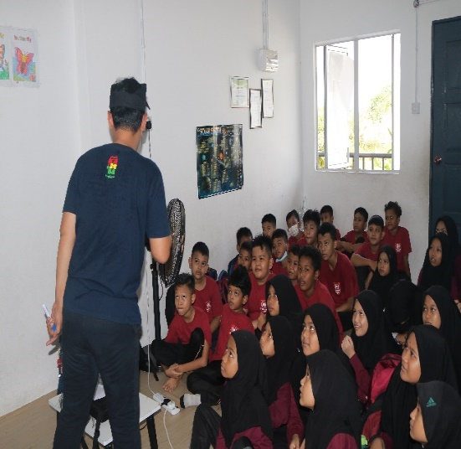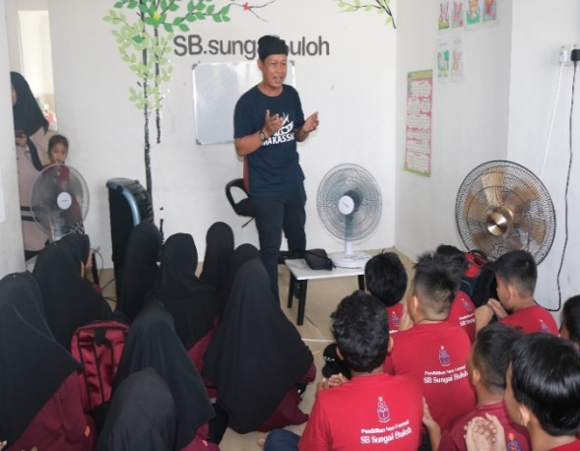

**Fig 3.** Provides an example of the Sing A Song method

1. **Evaluation Session**

After the participants practiced using the sing a song method book which can be used in conveying religious subject matter to students. So the training participants were asked to try and try it themselves by using the sing a song method when delivering religious subject matter, while the presenters and the team of presenters directly observed how the participants did in using the sing a song method in religious subjects. The results show that 89% of the training participants can know how to use the sing a song method in delivering religious subject matter in class.

**III. CONCLUSION**

The activities of the international partnership community service program (PkM-KI) are eagerly awaited by teachers who teach in guidance studios, especially Indonesian teachers who live abroad. Because, basically, they really hope for training activities that can improve their competence in terms of carrying out various cooperative learning methods, especially knowledge about how to use these methods in class. They hope that after they acquire this knowledge, they will be able to read the Koran properly and correctly when they want to read the Koran. The activities of the international partnership community service program (PkM-KI) that have been carried out are very useful, especially for guidance studio teachers around Kuala Lumpur , although it cannot be denied that the activities of the international partnership community service program (PkM-KI) that have been carried out very limited.

**IV. ACKNOWLEDGMENTS**

Thank you to the parties involved in carrying out international community service, including the Indonesian Ambassador to Malaysia, the Kualalumpur Indonesian School, the Sungai Buloh Guidance Center Malaysia, the UMSU Community Service Research Institute.

**REFERENCES**

1. S. N. H. H. Juli Maini Sitepu, “Meningkatkan Kemampuan Kreativitas Anak Melalui Media Permainan Bounch Magic Ball Pada Kelompok A Di Ra Al-Fathin Kecamatan Medan Belawan,” pp. 1–23, 2016.
2. Hasanuddin and N. Ginting, “Implementasi Konsep Pendidikan Islam Terpadu di Sekolah Islam Terpadu Ulul Ilmi Islamic School Medan,” ***Al-Muaddib J. Ilmu-Ilmu Sos. dan Keislam****.*, vol. 5, no. 2, pp. 293–304, 2020, [Online]. Available: http://jurnal.um-tapsel.ac.id.
3. Gunawan and R. Fanreza, “The Implementation of Character Values Through Al-Islam and Kemuhammadiyahan at Sekolah Menengah Pertama Muhammadiyah 01 Medan,” vol. 477, no. Iccd, pp. 272–274, 2020, doi: 10.2991/assehr.k.201017.059.
4. M. A. Nurzannah, J. M. Sitepu, and S. Psi, “Analysis of Text Books of Early Islamic Education in Primary Schools (Published by Erlangga and Yudhistira),” *Proceeding Int. Semin. Islam. Stud.*, vol. 1, pp. 598–608, 2019.
5. S. Edi, “Pembinaan Jamaah Dengan Metode Tadabbur Al-Quran Di Perhimpunan Keluarga Besar-Pelajar Islam Indonesia Sumatera Utara,” ***Ihsan J. Pengabdi. Masy.*,** vol. 2, no. 2, 2020, doi: 10.30596/ihsan.v2i2.5335.